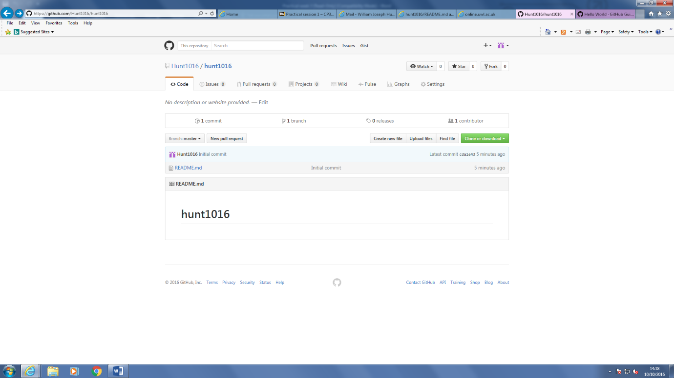

A1.

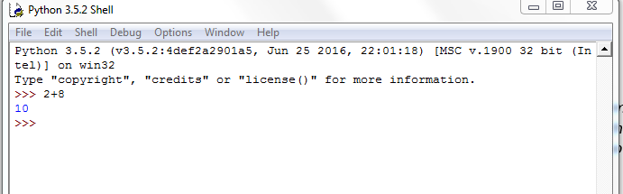

A2.a

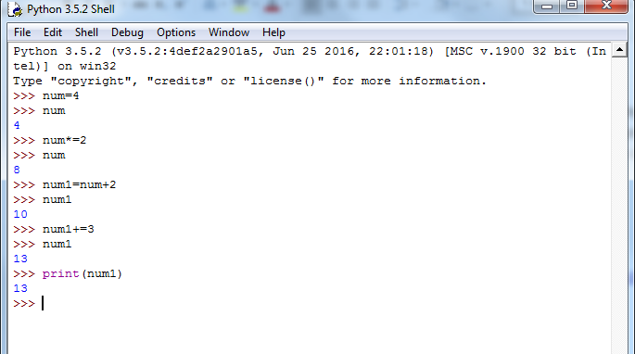

A2.b (2//3) will give you the answer rounded to the nearest whole number whilst (2/3) will give you the exact number you are looking for.

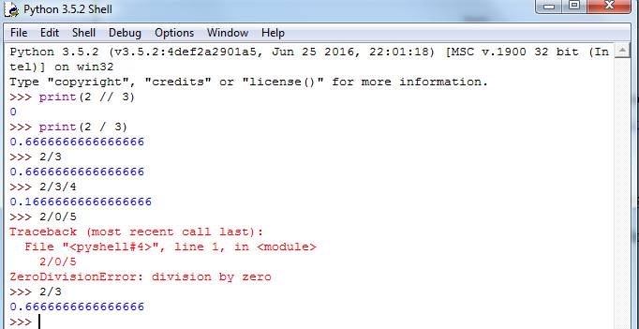

Q3. Variables usually starts with a lower case so I think that “areaOfRectangle” is the best to use because it is very informative of what the variable would actually mean compared to the others.

Q4. Not allowed to start with a number

Return is one of the variables that is not allowed in python because it is already a command. Out of all the other variables that were shown the ones starting with a number or had a “dot” with the line are not allowed in python. And ones with a number at the beginning (1Apple) is also not allowed in python.